SIMATS ENGINEERING
SAVEETHA INSTITUTE OF MEDICAL AND TECHNICAL SCIENCES

Department | AIML
Course Code / Course Name | DSA0601 / Data Handling and Visualization
Experiment | Data Visualization using R
Name | A Shiva Shankar Reddy
Register Number | 192425174
Date | 29 September 2026
Day | Tuesday

PROGRAM 1: Line Chart to Visualize Employee Performance
Question 1
Create a line chart to visualize the performance trend of employees over time. Include a legend and labels.
Aim
To create a line chart using R to visualize employee performance with proper title, axis labels, and legend.
R Program
R
employee <- c(1, 2, 3, 4, 5)
score <- c(85, 92, 78, 90, 76)
plot(employee, score,
type = "o",
col = "blue",
pch = 19,
main = "Employee Performance Trend",
xlab = "Employee ID",
ylab = "Performance Score")
legend("topright",
legend = "Performance",
col = "blue",
lty = 1,
pch = 19)

grid()
Output
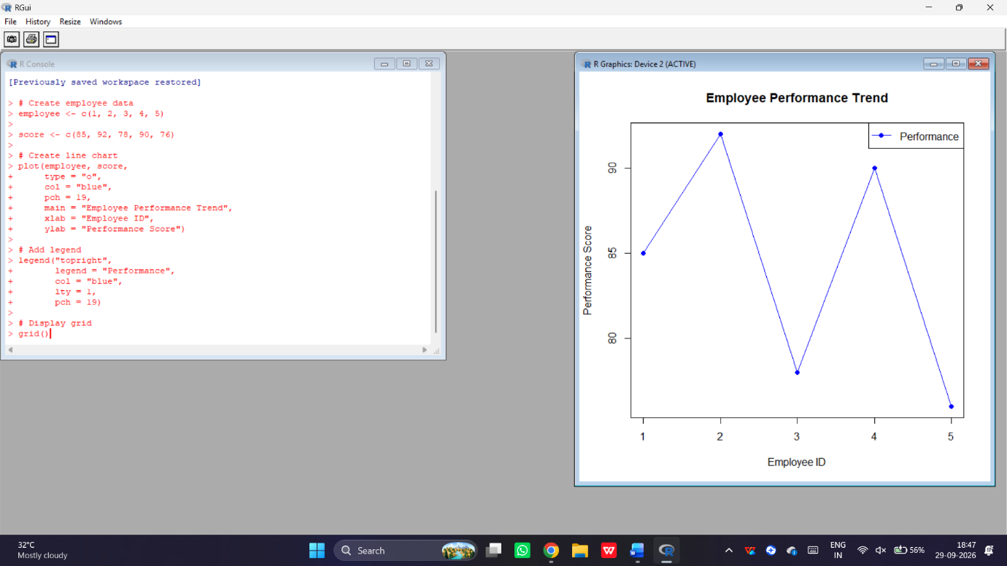
Expected Observation:
- Employee 2 has the highest performance score of 92.
- Employee 5 has the lowest performance score of 76.
- The chart shows variations in employee performance.
Result
Thus, the line chart representing employee performance was successfully created using R.
PROGRAM 2: Bar Chart for Department Distribution
Question 2
Generate a bar chart showing the distribution of employees across different departments. Label the chart elements.
Aim
To generate a bar chart using R to show the distribution of employees across different departments with proper labels.
R Program
R
department <- c("Sales", "HR", "Marketing", "Sales", "HR")

count <- table(department)
barplot(count,
col = "skyblue",
main = "Employee Distribution by Department",
xlab = "Department",
ylab = "Number of Employees",
border = "black")
grid()
Output
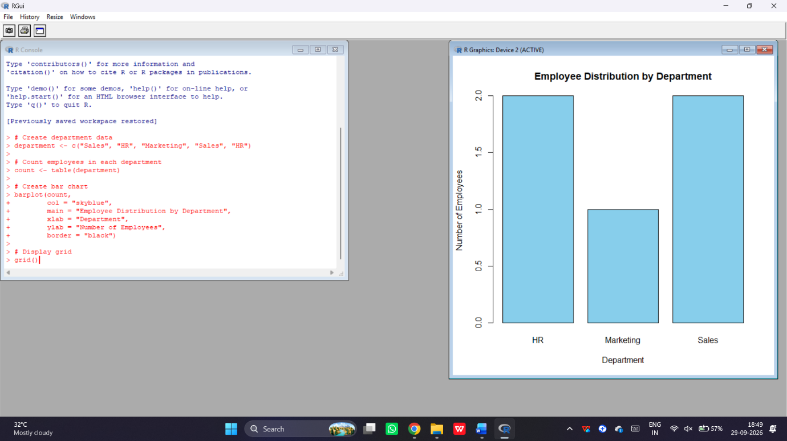
Expected Frequency:
Department | Employees
HR | 2
Marketing | 1
Sales | 2
Result
Thus, the bar chart showing employee distribution across departments was successfully created using R.
PROGRAM 3: Scatter Plot for Years of Service and Performance Score
Question 3
Build a scatter plot to analyze the correlation between years of service and performance scores. Explain any insights.
Aim
To create a scatter plot using R to analyze the relationship between years of service and employee performance scores.
R Program
R
years <- c(5, 3, 7, 4, 2)
score <- c(85, 92, 78, 90, 76)
plot(years, score,
pch = 19,
col = "red",
main = "Years of Service vs Performance",
xlab = "Years of Service",
ylab = "Performance Score")
abline(lm(score ~ years), col = "blue")
cor(years, score)
grid()

Output
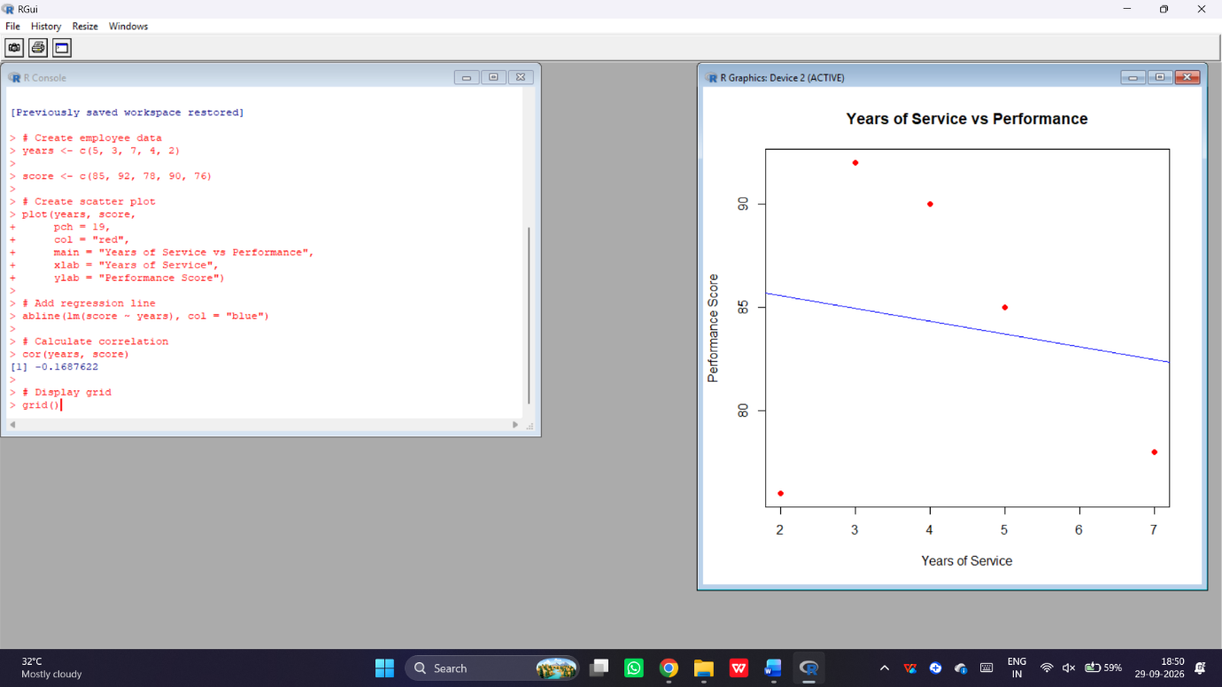
Console Output:
[1] -0.1688
Expected Observation:
- The correlation indicates a weak negative relationship.
- Years of service alone does not explain employee performance.
- Employee performance varies across different service durations.
Result
Thus, the scatter plot was successfully created and the relationship between years of service and performance scores was analyzed using R.
Question 4
Develop a Tableau dashboard with the line chart and bar chart for interactive exploration of employee performance data.
Aim
To develop an interactive Tableau dashboard combining a line chart and bar chart for employee performance analysis.

Code:
library(shiny)
employee <- c(1, 2, 3, 4, 5)
department <- c("Sales", "HR", "Marketing", "Sales", "HR")
score <- c(85, 92, 78, 90, 76)
data <- data.frame(employee, department, score)
ui <- fluidPage(
titlePanel("Employee Performance Dashboard"),
plotOutput("line"),
plotOutput("bar")
)
server <- function(input, output) {
output$line <- renderPlot({
plot(data$employee, data$score,
type = "o",
col = "blue",
pch = 19,
main = "Employee Performance Trend",
xlab = "Employee ID",
ylab = "Performance Score")

grid()
})
output$bar <- renderPlot({
count <- table(data$department)
barplot(count,
col = "skyblue",
main = "Employee Distribution by Department",
xlab = "Department",
ylab = "Number of Employees")
grid()
})
}
shinyApp(ui = ui, server = server)
The dashboard displays:
- Line chart – Employee Performance Trend.
- Bar chart – Employee Distribution by Department.

Output:
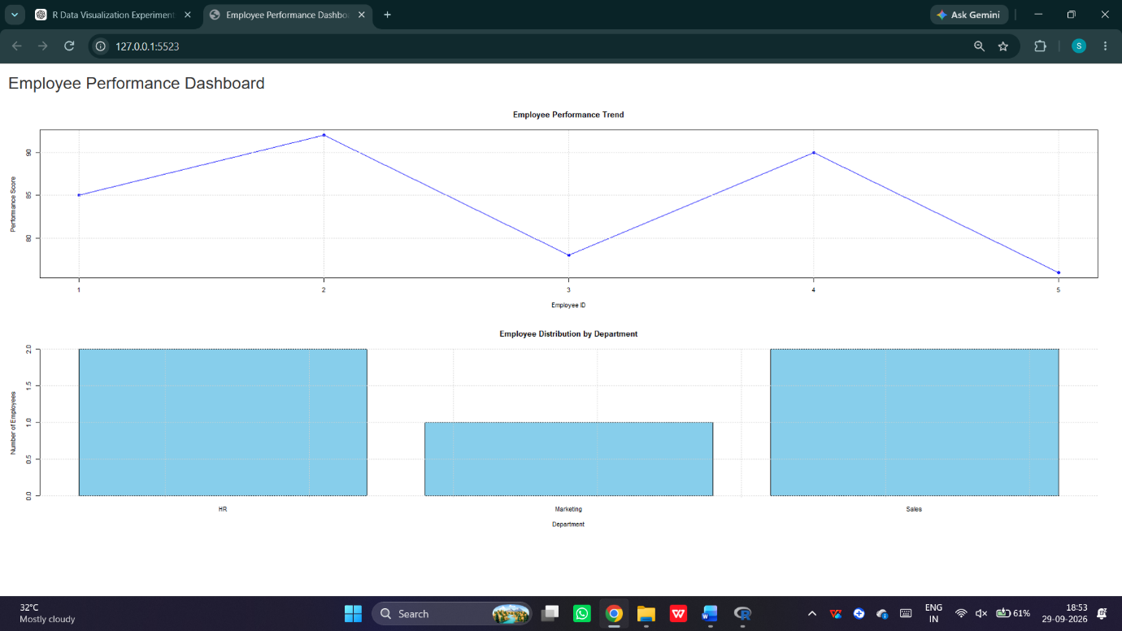
Result
Thus, an employee performance dashboard combining a line chart and bar chart was successfully developed using R Shiny.

